Data cleaning:involves identifying inaccuracies in a dataset and then fixing them.

Check for missing values

Check for duplicates

Standardizing and transformation:convert data into more efficient format.all uppercase or lower etc.

Updating data

Checking missing values and removing it:

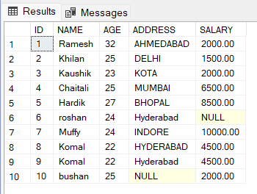

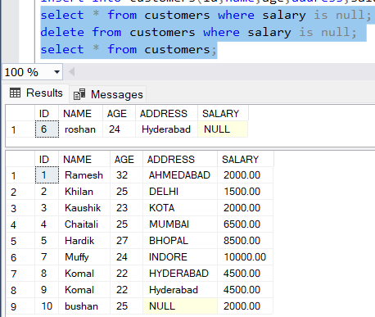

Checking duplicate values and removing it:

First how to find the duplicate rows:

Deleting duplicate values:

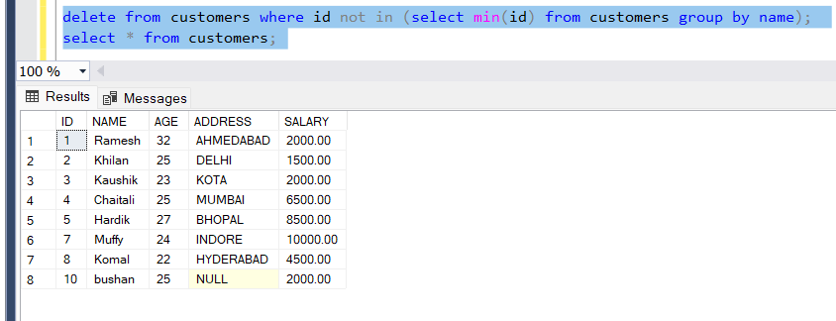

Using rownumber and partitions:

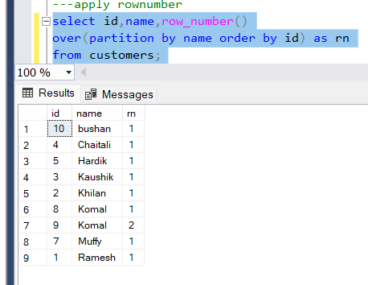

Now we can delete rows who have rn values >1

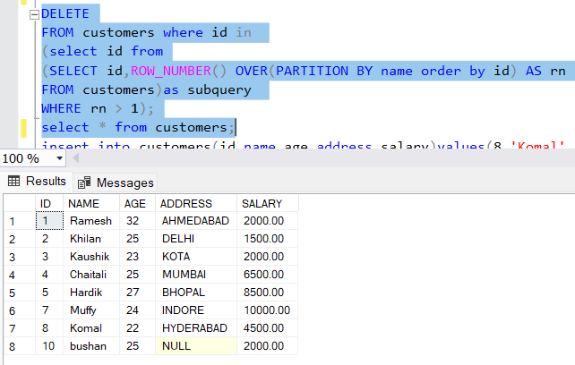

Removing null values:

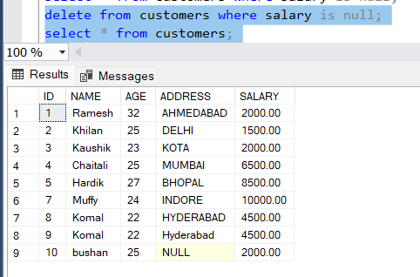

Updating null values:

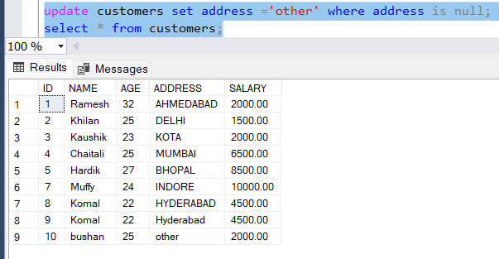

Partition:

Is a subclass of over clause,it divides based on the given column types.

Below is saleslist table:

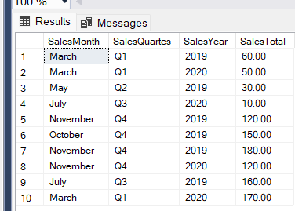

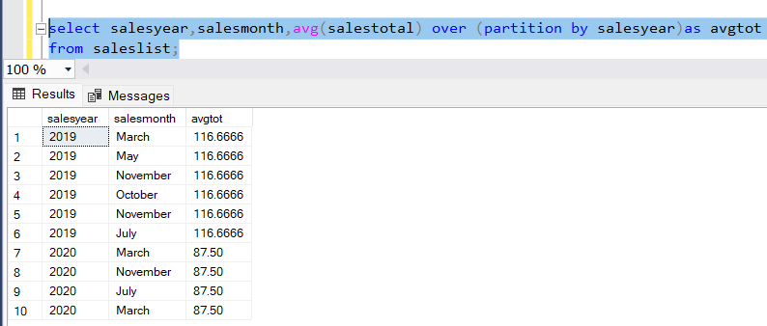

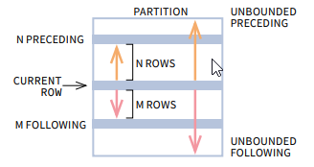

|  |  |  |
| --- | --- | --- |
| Just empty OVER() clause | UNBOUNDED PRECEDING | UNBOUNDED FOLLOWING |
| OVER(PARTITION BY …) | UNBOUNDED PRECEDING | UNBOUNDED FOLLOWING |
| OVER(PARTITION BY … ORDER BY …) | UNBOUNDED PRECEDING | CURRENT ROW |

A star schema consists of a central fact table that references multiple dimension tables. Each dimension table is denormalized ("flattened") to avoid the query overhead that comes with a highly normalized schema, which can require a large number of joins to retrieve the necessary data.

In a snowflake schema, a fact is surrounded by its associated dimensions (as in a star schema), but those dimensions are further related to other dimensions, branching out into a snowflake pattern. Snowflaking normalizes the dimensions by moving attributes with low cardinality into separate dimension tables.